**More than 100 e-vehicle companies likely to participate in second E-Vehicle Show India (India Today)**

*A three-day-long mega show of electronic vehicles is being organised in New Delhi where latest e-vehicles, hybrid vehicles, clean energy technology and advancements in alternative transport will be showcased.*

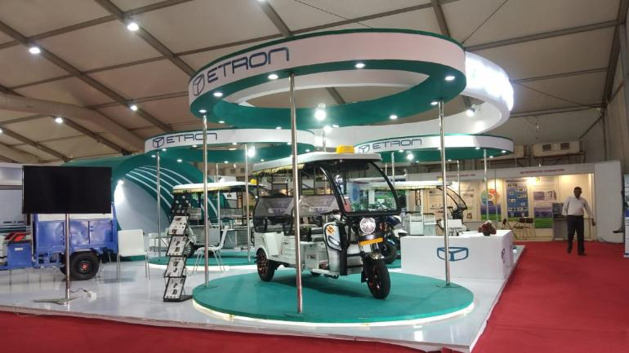

Exhibition in New Delhi is showcasing different electric vehicles and clean energy technologies | Photo courtesy: Nayanika Singhal

## HIGHLIGHTS

* Second BV Tech Expo India and E-Vehicle Show India was kicked-off from March 22
* Events at NSIC exhibition complex in Delhi were organised by M7 Creation
* Exhibition is showcasing electric vehicles, clean energy technologies and new and better battery technologies

The pollution level in India is getting worse day-by-day and the fuel used in the vehicles does more damage to our environment.

Hence, clean energy vehicles are the need of the hour.

A three-day-long mega show of electronic vehicles is being organised in New Delhi where latest e-vehicles, hybrid vehicles, clean energy technology and advancements in alternative transport will be showcased.

Second **'BV Tech Expo India'** and second **'E-Vehicle Show India'** have been kicked-off from March 22, at NSIC exhibition complex in Delhi organised by M7 Creation. The exhibition is showcasing electric vehicles, clean energy technologies and new and better battery technologies.

EV company of the year Mahindra Electric, EV 3-wheeler vehicles of the year Kinetic, EV bus of the year Olectra-BYD, Redmoto and more than 100 renowned companies are showcasing their vehicles in this mega fest of e-vehicles supported by Society of Manufacturers of Electric Vehicles (SMEV).

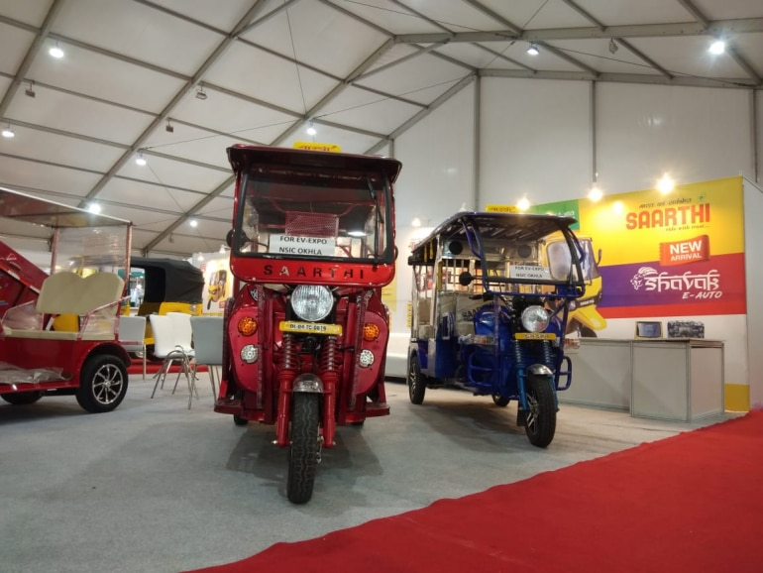

E-rickshaws displayed at the show in New Delhi | Photo courtesy: Nayanika Singhal

The Avan Motors India launched its Xero series of electric scooters.

The high-performance Trend E has an ex-showroom price of Rs 56,900 for the single-battery scooter and Rs 81,269 for the double-battery scooter.

The scooter can be booked from today (March 22) onwards at a nominal booking fee of Rs 1,100.

The three-day mega festival on battery vehicles and electric vehicles started with inaugural ceremony in the presence of director general of SMEV Shinder Gill and Mayor East Delhi Vipin Bihari Singh.

DG SMEV Shinder Gill said, **"Government has recently approved the FAME-2 policy but FAME-2 and FAME-1 both have a different segment in electric vehicle."**

He said, **"FAME-1 use to give the fixed subsidy to the consumer if you bring the certified vehicle; there was a subsidy of Rs 22,000 especially for the two-wheelers."**

DG SMEV Shinder Gill said, **"The government has now changed the policy in FAME-2 and interlinked it with battery which means 'more battery, more subsidies'."**

He also added that the subsidised vehicles will be sold till March 31 with the subsidy amount of Rs 22,000 and after that the vehicle subsidy will reduce to Rs 10,000 and a vehicle's cost will increase up to Rs 12,000.

Shinder Gill said that in FAME-2 policies of electric vehicles the battery cost is Rs 25,000 but since the government subsidies come into play, it will be costing Rs 15,000 only and the best company which is producing batteries is Exicom. In the last calendar year there were 55,000 e-vehicles which were sold in the market.

During the event, organiser of the expo Anupreet Singh Jaggi said, **"Central cabinet approval for the FAME-2 was a demand of time. The level of pollution in India is getting worse every day. Especially, the fuel used in vehicles is causing more damage to our environment. In such times the government has decided to encourage e-vehicles and is preparing to bring in more of these e-vehicles on roads. However, a detailed governmental policy in this regard is still awaited but there is no doubt 'Josh High Hai' and emotions are positive. With the support of Rs 10,000 crore to FAME-2, it is a clear message that this government is determined to increase the mobility of e-vehicles in the country. In this way, we are also supporting ourselves by encouraging the participation of new technologies in the BV Tech Expo and India E-Vehicle Show so that it can help reduce the country's fuel dependence through e-vehicles."**

Pankaj Tiwari, business development head, Avan Motors, said, **"The electric vehicles industry is on its growth trajectory and we are very confident of the market sentiment. We have also received a positive response for our products Xero, Xero+ and newly unveiled Trend E. Avan Motors's extensive R&D has led to the creation of a scooter that's a powerful mix of technology and design to meet the needs of the modern riders. With the growth in demand for our e-scooters, we have received multiple dealership requests and we are looking to expand aggressively in the market."**

[Avan Motors India launches 'Trend E' smart electric scooter, price starts at Rs 56,900](https://www.indiatoday.in/auto/new-launches/story/avan-motors-india-trend-e-launched-smart-electric-scooter-price-starts-at-rs-56900-1484272-2019-03-22)

[Toyota, Suzuki to collaborate on development of hybrid electric vehicles and compact vehicle engines](https://www.indiatoday.in/auto/latest-auto-news/story/toyota-suzuki-to-collaborate-on-development-of-hybrid-electric-vehicles-and-compact-vehicle-engines-1482803-2019-03-20)

<https://youtu.be/4akfkPF-35I>

SITE

<http://www.eai.in/ref/reports/India-electric-vehicles-expert-guide>

site useful

<https://medium.com/@an223c/trends-challenges-and-future-for-electric-vehicles-in-india-b6191f4a70b6>

report by ibef

[www.ibef.org/download/Automobiles-Nov-2018.pdf](http://www.ibef.org/download/Automobiles-Nov-2018.pdf)

accecture report

<https://www.accenture.com/_acnmedia/pdf-37/accenture-electric-vehicle-market-attractiveness.pdf>

google search

: electric vehicle market in india pdf

: future of electric vehicle in india

: NITI aayog report on ev (electric vehicle )